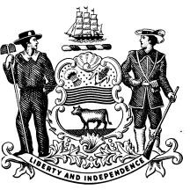
STATE OF DELAWARE DEPARTMENT OF TRANSPORTATION
DIVISION OF MOTOR VEHICLES

VEHICLE TRANSFER NOTIFICATION WITH BUYER INFORMATION
If submitted with a Sold out of State form or Lease Turn-in,
buyer information listed (address/city/state/zip) must be outside of Delaware.
(Please complete all information)

I, , sold my vehicle,
(Name of Seller)

Make:
Model:

Year:

VIN (Serial Number):

Tag Number: Odometer Reading (no tenths):

To:
(Name of Buyer)

Address:

Sale Date:
(City/State/Zip)
Selling Price:
(Month/Day/Year)

(Street Address)

(Signature of Seller) (Date)

(Signature of Buyer)

(Buyer's Drivers License No.)

(Date)

Revised 4/22

