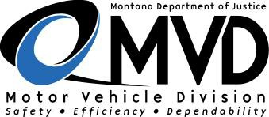  Title and Registration Bureau | Bill of Sale | Office Use Only
1003 Buckskin Drive, Deer Lodge, MT 59722-2375 • Phone (406) 846-6000 Fax (406) 846-6039 • mvdtitleinfo@mt.gov

*** This form must be completed in its entirety ***

As recorded on this form, I have received the sum of dollars ($ ) and other valuable consideration, to sell, transfer and deliver to:
(Buyer)

(Address) my right, title and interest to the following described vehicle/vessel:

Year Make Model Style Vehicle/Hull Identification No. License No.
Salvage Vehicle (must be 5 years or older): Yes No Sold for parts only: Yes No
I certify that I am the lawful owner of said vehicle/vessel and that (check only one): No security interest or lien exists against this vehicle/vessel.
There is a security interest or lien in favor of:

Secured Party Name:
Street Address
City
State
Zip Code

I further certify that:
- I have the right to sell the vehicle/vessel described above and will warrant and defend the title against the claims and demands of all persons except the secured party noted above.
- Under penalty of law (Unsworn Falsification to Authorities, Section 45-7-203, Montana Code Annotated,) the statements made on this form are true and correct to the best of my knowledge, information and belief, and if signing for a commercial entity, I have full authority to do so.

Seller’s Signature: Date:
This is my legal signature

Seller’s Printed Name:

If signing for a commercial entity, give full entity name

Montana county and state authorities reserve the right to reject any form that has been altered
MV24 (04/06) This form is available in alternate formats for people with disabilities

