Pennsylvania Advance Health Care Directive
This form lets you have a say about how you want to be treated if you get very sick.
This form has 3 parts. It lets you:
Part 1: Choose a medical decision maker.
A medical decision maker is a person who can make health care decisions for you if you are too sick to make them yourself.
Part 2: Make your own health care choices.
This form lets you choose the kind of health care you want.
This way, those who care for you will not have to guess what you want if you are too sick to tell them yourself.
Part 3: Sign the form.
It must be signed before it can be used.
You can fill out Part 1, Part 2, or both.
Fill out only the parts you want. Always sign the form in Part 3. 2 witnesses need to sign on page 11.

YOUR NAME:
Pennsylvania Advance Health Care Directive
If you only want to name a medical decision maker go to Part 1 on page 3.
If you only want to make your own health care choices go to Part 2 on page 6.
If you want both then fill out Part 1 and Part 2.
Always sign the form in Part 3 on page 9. 2 witnesses need to sign on page 11.
What if I change my mind?
s Fill out a new form. s Tell those who care for you about your changes.
s Give the new form to your medical decision maker and doctor.

What if I have questions about the form?
Ask your doctors, nurses, social workers, friends or family to answer your questions. Lawyers can help too.
What if I want to make health care choices that are not on this form?
Share this form and your choices with your family, friends, and medical providers.

Write your choices on page 9.
2
Pennsylvania Advance Health Care Directive

Part 1 Choose your medical decision maker
The person who can make health care decisions for you if you are too sick to make them yourself.
Whom should I choose to be my medical decision maker?
A family member or friend who:
s is at least 18 years old s knows you well

s can be there for you when you need them s you trust to do what is best for you
s can tell your doctors about the decisions you made on this form
Y our decision maker cannot be your doctor or someone who works at your hospital or clinic, unless he/she is a family member.
What will happen if I do not choose a medical decision maker?
If you are too sick to make your own decisions, a person
will be chosen for you according to Pennsylvania law. This person may not know what you want.

What kind of decisions can my medical decision maker make?
Agree to, say no to, change, stop or choose: s doctors, nurses, social workers s hospitals, clinics, or where you live s medications, tests, or treatments
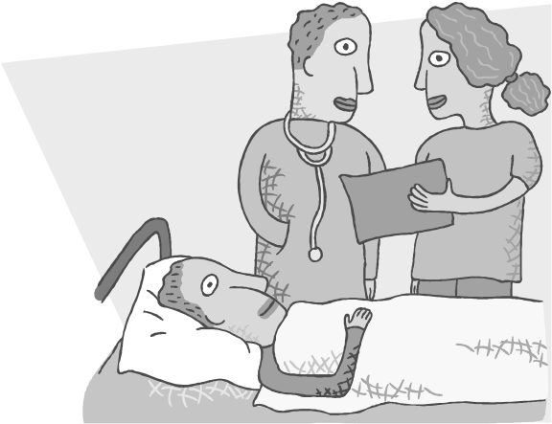
s what happens to your body and organs after you die
Your decision maker will need to follow the health care choices you make in Part 2.
Part 1: Choose your health care agent | Pennsylvania Advance Health Care Directive
Other decisions your medical decision maker can make:
Life support treatments – medical care to try to help you live longer
s CPR or cardiopulmonary resuscitation
cardio = heart pulmonary = lungs resuscitation = to bring back
This may involve:
  - pressing hard on your chest to keep your blood pumping
  - electrical shocks to jump start your heart
  - medicines in your veins
s Breathing machine or ventilator
The machine pumps air into your lungs and breathes for you.
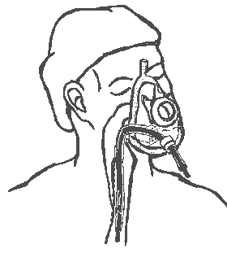
You are not able to talk when you are on the machine.

s Dialysis
A machine that cleans your blood if your kidneys stop working.
s Feeding Tube
A tube used to feed you if you cannot swallow. The tube is placed down your throat into your stomach. It can also be placed by surgery.

s Blood transfusions
To put blood in your veins.

s Surgery s Medicines
End of life care – if you might die soon your medical decision maker can:
  - call in a spiritual leader

  - decide if you die at home or in the hospital
  - decide where you should be buried
Show your medical decision maker this form.
Tell your decision maker what kind of medical care you want.
4
Part 1: Choose your medical decision maker Pennsylvania Advance Health Care Directive
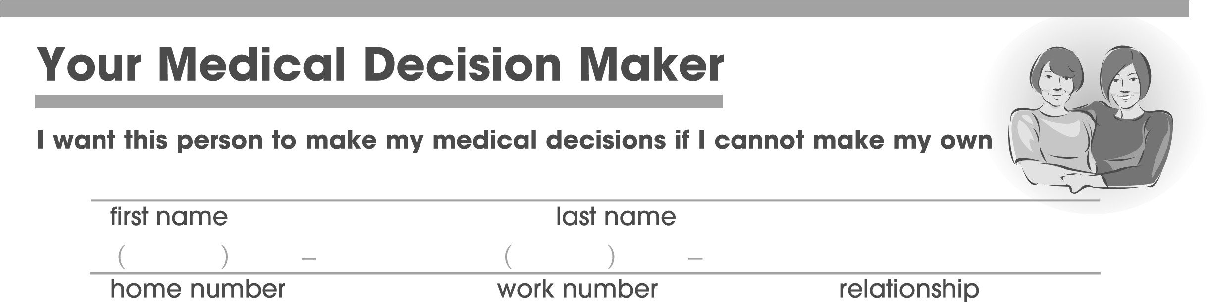
street address city state zip code
If the first person cannot do it, then I want this person to make my medical decisions. Also, if the first person is a spouse and you divorce, the doctors will turn to this person.

first name last name
( ) – ( ) –

home number |  |  | work number |  | relationship
street address |  |  | city |  | state zip code
Put an X next to the sentence you agree with.
- My medical decision maker can make decisions for me right after I sign this form.
- My medical decision maker will make decisions for me only after I cannot make my own decisions.
How do you want your medical decision maker to follow your healthcare wishes? Put an X next to the one sentence you most agree with.
- Total Flexibility: It is OK for my decision maker to change any of my medical decisions if my doctors think it is best for me at that time.
- Some Flexibility: It is OK for my decision maker to change some of my decisions if the doctors think it is best. But, these are some wishes I never want changed:

- No flexibility: I want my decision maker to follow my medical wishes exactly, no matter what. It is not OK to change my decisions, even if the doctors recommend it.
To make your own health care choices go to Part 2 on the next page.
If you are done, you must sign this form on page 9.
Pennsylvania Advance Health Care Directive
Part 2 Make your own health care choices
Write down your choices so those who care for you will not have to guess.
Think about what makes your life worth living.
Put an X next to all the sentences you most agree with.
My life is only worth living if I can:
m talk to family or friends m wake up from a coma
m feed, bathe, or take care of myself m be free from pain m live without being hooked up to machines m My life is always worth living no matter how sick I am m I am not sure
If I am dying, it is important for me to be:
- at home o in the hospital o I am not sure
Is religion or spirituality important to you?
- no o yes If you have one, what is your religion?

What should your doctors know about your religious or spiritual beliefs?

If you are sick, your doctors and nurses will always try to keep you comfortable and free from pain.
YOUR NAME:
6

Life support treatments are used to try to keep you alive. These can be CPR, a breathing machine, feeding tubes, dialysis, blood transfusions, or medicine.
Please read this whole page before you make your choice.
Put an X next to the one choice you most agree with.
If I am so sick that I may die soon:
- Try all life support treatments that my doctors think might help. If the treatments do not work and there is little hope of getting better, I want to stay on life support machines even if I am suffering.
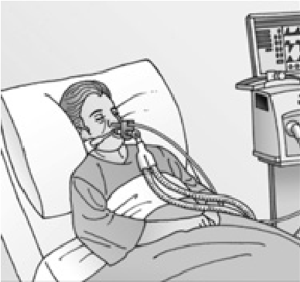
- Try all life support treatments that my doctors think might help. If the treatments do not work and there is little hope of getting better, I do NOT want to stay on life support machines. If I am suffering, I want to stop.
- I do not want life support treatments, and I want to focus on being comfortable. I prefer to have a natural death.
- I want my medical decision maker to decide for me.
- I am not sure.
*If you are pregnant and become unable to make decisions: Pennsylvania law may require your doctor to give you life support treatments even if you have an advance directive.
If you want to write down medical wishes that are not on this form, go to page 9.
YOUR NAME:
Your doctors may ask about organ donation and autopsy after you die. Please tell us your wishes.
Put an X next to the one choice you most agree with. Donating (giving) your organs can help save lives.
- I want to donate my organs. Which organs do you want to donate?
m any organ

m only____________________________
- I do not want to donate my organs. o I want my decision maker to decide. o I am not sure.
An autopsy can be done after death to find out why someone died. It is done by surgery. It can take a few days.
- I want an autopsy. o I do not want an autopsy.
- I only want an autopsy if there are questions about my death. o I want my decision maker to decide. o I am not sure.
What should your doctors know about how you want your body to be treated after you die? Do you have funeral or burial wishes?

8
YOUR NAME:

What other wishes are important to you?

Part 3
Sign the form

Before this form can be used, you must:

s

sign this form if you are at least 18 years of age

s
have two witnesses sign the form
Sign your name and write the date.
/ /

sign your name date

print your first name print your last name

address city state zip code

Pennsylvania Advance Health Care Directive
Your witnesses must:
B efore this form can be used you must have

2
witnesses sign the form
Part 3
Witnesses
s be over 18 years of age s know you s see you sign this form Your witnesses cannot:
s be your medical decision maker s be your health care provider s work for your health care provider s work at the place that you live Also, one witness cannot:
s be related to you in any way s benefit financially (get any money or property) after you die
Witnesses need to sign their names
on the next page.
10
Have your witnesses sign their names and write the date
By signing, I promise that ______________________ signed this form while I watched.
(name)
He/she was thinking clearly and was not forced to sign it. I also promise that:
s I know this person and he/she could prove who he/she was.
s I am 18 years or older s I am not his/her medical decision maker s I am not his/her health care provider s I do not work for his/her health care provider s I do not work where he/she lives One witness must also promise that:
s ) AM NOT RELATED TO HIMHER BY BLOODMARRIAGEOR ADOPTION
Part 3: Sign the form | Pennsylvania Advance Health Care Directive

s ) WILL NOT BENEFIT FINANCIALLY GET ANY MONEY OR PROPERTY AFTER HESHE DIES
Witness #1

/ /
sign your name | date
print your first name | print your last name
address | city state | zip code
Witness #2 | / /
sign your name | date

print your first name print your last name

address city state zip code

You are now done with this form.

Share this form with your family, friends, and medical providers.
Part 3: Sign the form | Pennsylvania Advance Health Care Directive
Talk with them about your medical wishes
This advance directive is in compliance with the Pennsylvania Probate Code 20 PA. C.S.A. §§ 5421-5431. 12 © 2015 Rebecca Sudore, MD
This work is licensed under the Creative Commons Attribution-NonCommercial-ShareAlike License. http://creativecommons.org/licenses/by-nc-sa/2.0/
Revised 3/10/2015
PATEX415377 SR/SK 03/15

